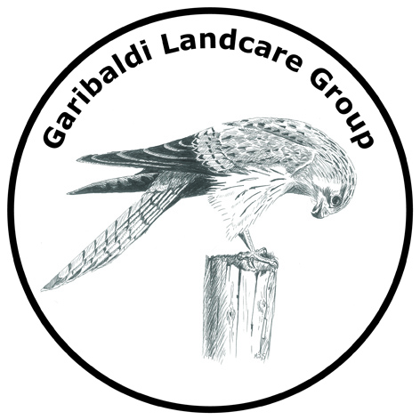

About the Garibaldi Landcare Group (GLG)

GLG is a Landcare Group within the Leigh Catchment Group area 

We aim:

* To protect, enhance and restore the remnant vegetation and wildlife habitat on public and private land in our area.
* To assist and inform local landholders on best sustainable land management practices and provide Landcare information.
* To encourage landholders to use indigenous native species in their gardens and land revegetation projects to improve the habitat for our native fauna species.
* To source funding to assist with environmental works.
* To involve the local community in environmental projects on public land reserves.
* To link, involve and educate other groups including city based groups and educational establishments



Public Land Projects:

GLG manages three main public land sites.

* Garibaldi Bridge Reserve
* South Durham Bridge Reserve
* Hardies Hill Water Reserve

Our Special Ongoing Project:

*Garibaldi Walking Track* from South Durham Bridge to Garibaldi Bridge via the Garibaldi Hall.

Nearly 10,000 plants have been planted along the Yarrowee River through the Durham Lead and Garibaldi area.

The walking track, fencing and reserve weed management have been grant funded.

Supporting Partners:

* City of Ballarat
* Golden Plains Shire
* Ballarat Environment Network
* Department of Sustainability and Environment
* Department of Primary Industries
* Corangamite Catchment Management Authority



Benefits of Membership:

* Workshops including speakers/hands on activities on environmental issues.
* Working bees to improve and maintain our local environment.
* Information on natural resource management issues.
* Access to funding opportunities for on ground works; fencing, revegetation, remnant protection, erosion etc.

Watch the email (members), local newsletter and notice boards in Buninyong for coming events and workshops.

*If there is a particular area of interest that you would like to be discussed at a general meeting, please send your suggestions to the Secretary.*

How to join:

Fill out the membership form enclosed:

Send it with a cheque for your annual family membership to:

The Treasurer, Garibaldi Landcare Group

*or*

Drop it with cheque or cash for your annual family membership to:

The Leigh Catchment Office

407 Warrenheip Street,

Buninyong, Vic 3357

Family Membership $15 (due end of June annually)