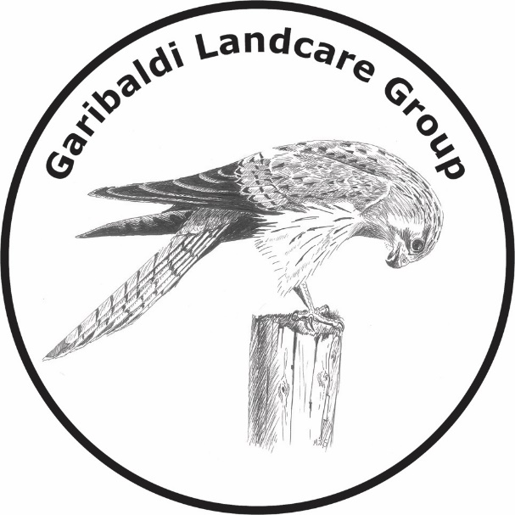
Committee:
Chair – Gayle Gilbert
Vice Chair – Gerard Zoutendijk
Secretary – Talia Barrett
Assistant Secretary – Jeanette Mitchell
Treasurer – Linda Wright
Committee member - Murray Gilbert

Mail: Garibaldi Landcare Group
101 Lockyers Road
Durham Lead 3352

Phone: 0432 219 308 (Linda)

Email: garibaldilandcare@gmail.com

Facebook: @garibaldilandcaregroup

For GLG membership please complete the GLG Membership Form, available on line at http://www.leighcatchmentgroup.org/garibaldi#join-our-group . Annual membership is $15, due 1st July.

Payment Options:

Direct Deposit
Garibaldi Landcare Group
BSB: 633 000
Account: 156815417
Reference: Your Surname

Cheque, money order by mail
Garibaldi Landcare Group
101 Lockyers Road,
Durham Lead 3352

Cash or cheque
Directly to a committee member along with the completed membership form.

Who are we?

Currently we have approx. 20 members, most of whom live around the Garibaldi area, from Buninyong through to Grenville (and a few from Ballarat)
We are all volunteers. Our committee, elected at our General Meeting in January, consists of 6 volunteer members.

We currently look after 3 areas of public land:
- Garibaldi Bridge Reserve
- South Durham Bridge Reserve
- Hardies Hill Reserve

What we are doing this year?

- Direct seeding and planting of wildflowers and understorey plants in South Durham Bridge Reserve and Garibaldi Bridge Reserve
- Weed control across all 3 reserves targeting gorse, blackberries, hemlock, spiny rush and herbaceous weeds.
- National Tree Day on Sunday 22nd July

What’s in it for you?

- Put your name on part of a reserve if you do the work.
- Access to free seeds and tubestock at cost price.
- Workshops including speakers/hands on activities
- Information about local flora and fauna
- Quarterly Landcare magazine
- Access via Landcare and Leigh Catchment Group for funding and resources for your own property.
- Networking within your local community

How do we work?

- Structured working bees and workshops, such as National Tree Day, on the 3rd Sunday of every second month.
- Ongoing project maintenance is carried out by members on an ad hoc basis individually or in small groups.
- We will continue planting and development in all of the reserves, with individuals / teams taking responsibility for each ‘plot’ at a time that suits them.

