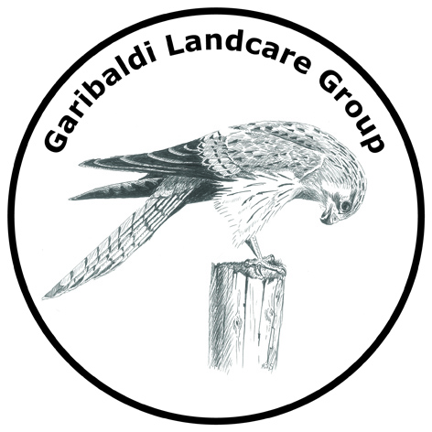

Committee:
Chair – Dave Holden
Vice Chair – Linda Wright
Secretary – Talia Barrett
Treasurer - Gemma Wilson
Peter Sedgwick
Gerard Zoutendijk

Mail: Garibaldi Landcare Group
105 South Durham Bridge Road,
Durham Lead 3352

Phone: 0409 593 154 (Gemma)

Email: garibaldilandcare@gmail.com

Facebook: @garibaldilandcaregroup

For GLG membership please complete the GLG Membership Form.

Payment Options:

Direct Deposit
Garibaldi Landcare Group
BSB: 633 000
Account: 156815417
Reference: Your Surname

Cheque, money order by mail
Garibaldi Landcare Group
105 South Durham Bridge Road,
Durham Lead 3352

Cash or cheque
Directly to a committee member along with the completed membership form.

GLG Membership Form

Family Membership $15.00
Due 1 July Annually

Name of Member(s)

Address

Postal Address (if different from above)

Email

Phone/Mobile

What is your preferred method of contact?

Email Post Facebook Message

SMS Phone ___________________________

Do you agree to share your contact information with fellow GLG Members?
I Agree
I DO NOT Agree

Signature _______________________________________________________________

Payment Options:

Direct Deposit
Garibaldi Landcare Group
BSB: 633 000
Account: 156815417
Reference: Your Surname

Cheque, money order by mail
Garibaldi Landcare Group
105 South Durham Bridge Road,
Durham Lead 3352

